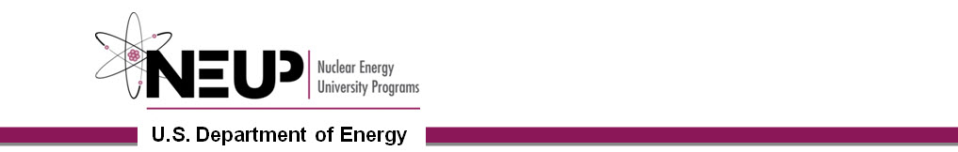
Foreign Travel Request Form

Complete this form in its entirety and submit as a Word file 45 days prior to your departure to Stefanie Johnston at Stefanie.Johnston@inl.gov. Contact NEUP at (208) 526-1197 with any questions.
Traveler Information
Responsible Program Office (at HQ), if overhead travel responsible program office is NE. |  | Nuclear Energy University Programs (NEUP)  Mike Worley
Traveler Name (Last, First, Middle) |  | Last, First, Middle
Social Security Number |  | XXX-XX- Last 4 Digits I do not have a SSN
Passport Number |  | Exp Date mm/dd/year
Gender |  | Male Female
Citizenship |  | a) First Country  b) Second Country
Permanent Resident Green Card Holder |  | Yes No
U.S. Visa |  | Visa Type Expiration Date  Not Applicable
Employment Information |  | Name  Position Title  Street Address  City State  Zip Country
Contact Information |  | Home Telephone  Cell Phone  Email Address  Work Phone  Work Fax
Section II. General Trip Information
Use additional pages as necessary. Account for all funding types estimated for this trip request.
Place of Departure | City  State/Province  Country
Departure/Return Date | Depart: mm/dd/year Return: mm/dd/year
Estimated Total Travel Costs | $ Airfare $  Other $
Project ID Number
Charge Number/B&R Code (NEUP will enter.)
Benefit to Government: Describe how you will use the information, etc. that you gain from the trip to benefit your present position, division, INL, and DOE HQ programs. Avoid a description of the trip itinerary. | Describe Benefit Here

Section III. Trip Itinerary
Use additional pages as necessary. Account for the entire time between departure and return. Complete a separate itinerary for each city/country to be visited and for each personal or leave period. (DOE allows only 2 personal days associated with foreign business travel.)
Is this part of the trip associated with a conference? | Yes No  (If yes, provide the information below.)  Conference:  Sponsor:  Contact URL:
Destination (Country, City) | Country, City
Start Date | mm/dd/year
End Date | mm/dd/year
Select One or More Primary Purposes | Professional Conference or Workshop  Seminar/Symposium  Working Group or Colloquia (Scientific Meeting)  Site Visit  R&D activities under an informal, lab-to-lab, or government-to-government agreement  Meeting(s) on scientific, technical, project or programmatic matters  Procurement-Related Matters  Official Stop Over  Personal Leave  IAEA Travel  LDRD Project Work  Permanent Change of Station
Technical Justification: Describe what you will be doing while on travel; be specific and as detailed as possible. | Describe Justification Here
Host/In-Country Contact Information | Name  Affiliated Institution  Phone
After Hours/Hotel Information | Name  Phone

