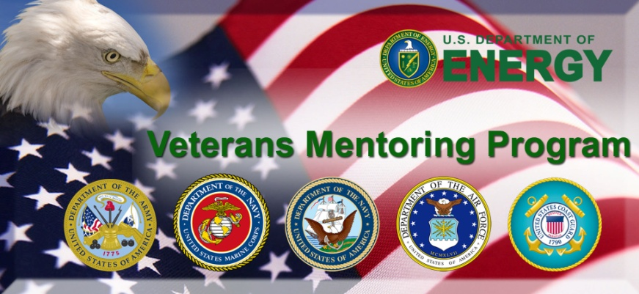
Mentee Profile
Program Year: 2012-2013

Personal Information
Name (First, Middle Initial, Last):

E-Mail Address: Work Phone:

Military Service
What branches of the military have you served in: (Circle All That Apply):
Air Force Army Coast Guard Marines National Guard Navy
Are you a combat Veteran? If so, which theater of operation?:
What was the last unit you were or are assigned to?:

Mentoring Interest

Please provide the below information:

1) Job history and major accomplishments:

2) Knowledge, skills and talents acquired during military service you wish to explore further in your
civilian career:

3) Degrees, certifications and areas of expertise:

4) Interests and hobbies:

5) Are there any specific topics you would like to learn more about, or questions you have, in regard to your
future career?:

6) What would you like to gain from this mentoring experience?:

7) Are there any preferences for your Mentor, i.e., Male / Female; Veteran/ Federal; Branch of Service?:

8) Is there anything else you wish to share about yourself in this profile not covered above?:

9) Is there anything else we should take into account when matching you with a mentor?:

10) I would _____ Would Not ______ consider virtual mentoring (Email, LinkedIn, FaceBook, Webinars, VTC)?:

11) I would consider this program a success if my Mentor and I accomplish :

Mentor Preferences (Please rank 1 – 3) if known at this time.
1. ________________________________
2. ________________________________
3. ________________________________

