STATEMENT FOR THE RECORD
Lee A. Hanse, Executive Vice President
Energy Transfer
Quadrennial Energy Review Public Meeting
Infrastructure Constraints

Bismarck, North Dakota – August 8, 2014
Removing Infrastructure Constraints in the Williston Basin
Thank you for the opportunity to provide these written remarks as part of the Quadrennial Energy Review Public Meeting in Bismarck, North Dakota. I am submitting my remarks as a representative of Energy Transfer, one of the largest and most diversified investment grade master limited partnerships in the United States. On a consolidated basis, our family of partnerships owns and operates approximately 71,000 miles of crude oil, refined product, natural gas, and natural gas liquids pipelines.
Figure 1 below highlights the asset base of the Energy Transfer family of partnerships. Through these assets, Energy Transfer provides market participants in the oil and gas industry with safe and reliable logistics services that bridge the gaps between supply and demand throughout the United States.
Figure 1: Energy Transfer Assets
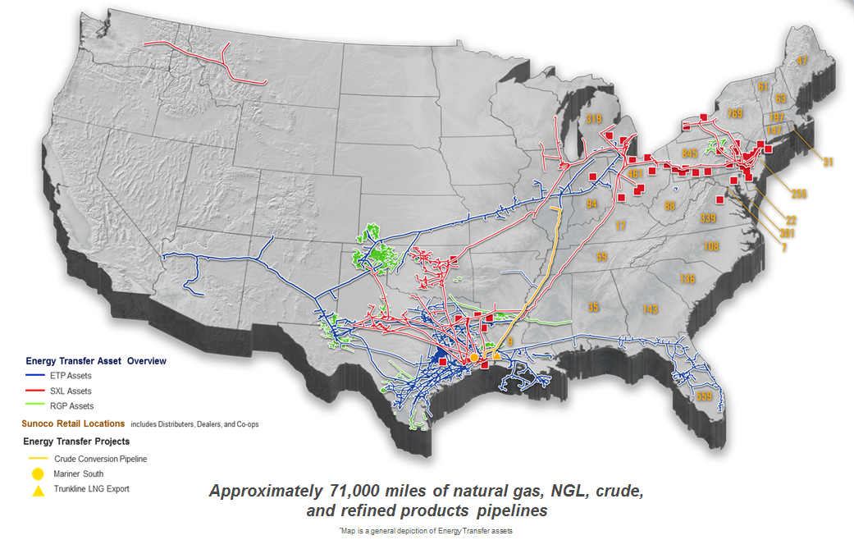
Whether it is our interstate natural gas pipeline system serving Nevada and California LDCs, our crude oil pipelines connecting production to Texas refineries, or our liquids pipelines transporting feedstock to chemicals manufacturers throughout the U.S. Gulf Coast, we develop and operate infrastructure to move energy products to where they are needed.
I am responsible for business development activities within Energy Transfer. We were fortunate to have had my colleague, Shelley Corman, participate as a panelist in the Quadrennial Energy Review in Pittsburg, Pennsylvania, on July 21, 2014. Understanding that the Department of Energy’s practice is not to have panelists from the same company at multiple public meetings, I appreciate this opportunity instead to share written comments with you. Energy Transfer has committed itself to removing key infrastructure constraints in the Williston Basin. In June, we announced a multi-billion dollar investment in new pipeline infrastructure to link Bakken/Three Forks crude oil production to Midwest and Gulf Coast refinery markets. Therefore, we value this chance to contribute to the dialogue about promoting responsible and balanced infrastructure development for the Williston Basin in particular and throughout the United States in general.
The Infrastructure Challenge
In the Presidential Memorandum that established this Quadrennial Energy Review process, the President highlighted that our current infrastructure is “increasingly challenged by transformations in energy supply, markets, and patterns of end use. . . .” It is no surprise, of course, that today’s public meeting on infrastructure constraints should then be held in North Dakota. The story of development in the Williston Basin, a central driver of the oil and gas renaissance in the United States, is a marvel when told through raw numbers. Already production has topped 1 million barrels of crude oil produced per day and over 1 billion cubic feet of natural gas per day. Yet the story is all the more astounding when viewed in the context of the logistical hurdles that have confronted market participants and other stakeholders in North Dakota and Montana. Simply put, our nation’s infrastructure has been engaged in an on-going game of “catch up” with the growth potential of the Bakken/Three Forks play in the Williston Basin, as well as other unconventional oil and gas plays throughout the country.
When growth of such scale and scope occurs quickly and unexpectedly, impediments arise in almost every aspect of the development process. Indeed, challenges in the Williston Basin have run the gamut from ensuring adequate lodging for personnel, to workforce training, to obtaining the rights of way for gathering pipelines. Solutions do not come easily because they require coordination of equivalent scale and scope. Industry participants must work together with local residents, governmental officials, public interest groups, and other stakeholders to earn and maintain the social license to operate. Oil and gas activities are capital intensive, so massive amounts of investment must be aggregated through the capital markets to fund the infrastructure build-out. Facilities must be designed, fabricated, and installed. Market participants must ensure that they can recruit, train, and maintain the “boots on the ground” to coordinate the massive logistical effort in the field. Among all these activities, a multitude of decisions about infrastructure investment must be made in the face of market, operational, and regulatory uncertainties. And all of this takes time.
The result is that suboptimal choices may be made, especially in the near term, and the pace of economic growth is thereby put at risk. Natural gas flaring and the measures taken to address that flaring serve as a prime example of how inadequate infrastructure can deter otherwise desired development. Beyond the oil and gas industry itself, congestion in the railroad network can negatively impact the region’s agriculture industry and passenger rail when greater crude oil volumes shift to rail because pipeline capacity is inadequate. What is happening in the oil and gas industry in the Williston Basin is certainly a testament to the ability of U.S. citizens to achieve monumental results through hard work and free enterprise despite logistical challenges. Nevertheless, the success also showcases the greater promise waiting to be secured, if we can enhance the policies aimed at supporting the infrastructure development that is required to harness our domestic energy resources.
Meeting the Pipeline Infrastructure Challenge
Energy Transfer is among the market participants that have committed themselves to solving the infrastructure challenge in the Williston Basin. Energy Transfer recently announced that two of its subsidiaries, Dakota Access, LLC (“DAPL”) and Energy Transfer Crude Oil Company, LLC (“ETCO”), have committed to make the multi-billion dollar investments necessary to safely, reliably, and cost-effectively link U.S.-produced Bakken/Three Forks light sweet oil directly by pipeline to U.S. refineries in the Midwest and the Gulf Coast. DAPL’s system will consist of approximately 1,100 miles of mainly 30-inch diameter pipeline to transport Bakkan/Three Forks production from key points of receipt in North Dakota to Midwest refineries. ETCO’s system will be approximately 750 miles of predominately 30-inch diameter pipeline, interconnecting with DAPL in Illinois to transport light sweet oil to the U.S. Gulf Coast. ETCO’s system will include approximately 700 miles of existing underutilized pipeline (i.e., nearly 95% of the system route) that is being converted from natural gas service to crude oil service, helping to mitigate environmental and landowner impacts of the ETCO project.
Today, both projects are immediate growth engines for American jobs throughout the U.S. They will create construction jobs across multiple states and drive growth for U.S. steel mills, manufacturers, and multiple service industries across the country. Once in service, DAPL’s in-field facilities will also help to reduce crude oil trucking and promote safer operations in the basin. Enhanced pipeline access for Bakken/Three Forks production to reach key domestic refining markets will support a healthier U.S. economy. It will positively impact everything from chemicals manufacturing costs to the price of gasoline and diesel at the pump. It will also contribute to improved international security for all Americans by further reducing our economic dependence on foreign crude oil from countries that are often either unstable or hostile to U.S. interests.
Making Progress from Here
Because the President established this Quadrennial Energy Review process with the goal of reviewing and improving federal energy policy, I would like to conclude with a few observations in that regard from my experience developing the DAPL and ETCO projects and others like it. Long-haul pipeline projects like those being developed by DAPL and ETCO are just a part of the infrastructure equation in the Williston Basin, of course, but the investment analysis is similar for other types of large infrastructure projects. In particular, Energy Transfer’s experience highlights two themes about how government can encourage infrastructure investment, whether it is for a pipeline, an electric transmission line, a hotel, or any other significant capital investment.
First, governmental agencies can facilitate infrastructure investment by building predictability into their approach to regulation. For example, the Federal Energy Regulatory Commission’s (“FERC”) ratemaking rules and policies for new crude oil pipeline infrastructure provided a critical foundation for securing the DAPL and ETCO projects. The rules and policies articulated by the FERC define the parameters under which the necessary customer commitments can be secured on a long-term basis. Two elements of what the FERC has done are especially important. The rules and policies are clearly communicated within agency precedent. Thus, DAPL and ETCO could negotiate with their prospective customers on the basis of a set of principles that all parties understood and could reference. Additionally, FERC’s rules and policies provide all parties with tools for identifying and allocating risk, as well as certainty that their agreements about those allocations will be respected. When Energy Transfer or any other infrastructure company evaluates a large-scale capital investment, regulatory clarity and certainty are critical elements of the investment equation.
Second, it is difficult to overstate the value of governmental agency policies and procedures that mediate between local interests and the needs of the broader community while still accommodating pressing project development timelines. Both industry and government have important roles to play in fostering an environment that is supportive of new infrastructure development at the local level. Each has a responsibility to the public to ensure that development occurs prudently and in a manner that balances various stakeholder interests. In this context, government and industry participants must both think creatively about how stakeholder participation can be encouraged in conjunction with, not at the expense of, timely decision making. The risk of material delay in permitting and other regulatory approvals can be difficult to overcome in investment decision making, given the impact to financial projections of a potential delay of revenues and the hesitation of customers to commit financially to new infrastructure projects without certainty around project timing.
While these are just two of many issues that influence the investment decisions of companies like Energy Transfer, they are key areas where governmental policy can help to influence the process of infrastructure development positively going forward.
Thank you again for the opportunity to provide these comments today. All of us are still at the beginning of the story in the Williston Basin, and these are critical issues for our nation. We will look forward to the progress that comes from this dialogue.

