MSSLC Model Specification for
LED Roadway Luminaires

Version 2.0

July 2014

Summary of Changes to the Previous Version (1.0)

- Formatting changes throughout.
  - Revised section numbering scheme and linked section references.
  - Replaced hidden text with comments.
  - Moved both versions of appendix A (System and Material) to section 4.1 of main text.
  - Moved nearly all decision points to section 4.1.
- References section
  - Added ANSI C82.77-2002 for power factor, THD, etc.
  - Added ANSI C136.2-2014 for electrical immunity and dielectric withstand.
  - Deleted ANSI C136.25 since not directly referenced.
  - Added ANSI C136.41-2013 for “controls-ready” photocontrol receptacle.
  - Updated RoHS to RoHS II.
  - Added ENERGY STAR TM-21 Calculator.
  - Added FCC 47 CFR since directly referenced.
  - Added FTC “Made in USA” guidance in lieu of ARRA “Buy American.”
  - Deleted IEEE C62.41.2 and C62.45 since not directly referenced.
  - Deleted IES DG-4, HB-10, and TM-12 since no longer directly referenced.
  - Updated IES LM-50 to new 2013 version.
  - Added IES LM-63.
  - Added LED Lighting Facts URL to align criteria.
  - Added MSSLC Model Specification for Networked Outdoor Lighting Control Systems.
  - Added NEMA LSD 63 for manufacturing tolerances and measurement uncertainties.
  - Deleted NFPA 70 (NEC) since not directly referenced.
  - Deleted UL 1449 and 8750 since not directly referenced.
- Clarified that whereas specifications for photocontrol receptacles are included, specifications for photocontrols are not.
- Clarified FCC restrictions in terms of “Class” rather than “consumer.”
- Updated CCT and Duv criteria to reflect minor changes to the new ANSI standard, and to accommodate slight differences in Nominal CCT between manufacturers.
- Simplified mesopic multiplier text for clarity and to align with draft IES RP-8 update.
- Leveraging new LED Lighting Facts guidance that has been adopted by the DesignLights Consortium:
  - Revised lumen maintenance criteria;
  - Deleted appendices B (lumen maintenance) and C (product family testing).
- Deleted appendix D (electrical immunity) to instead leverage ANSI C136.2-2014, which was updated to incorporate the appendix D criteria originally developed by the MSSLC.

Instructions for the Editor (Municipality, Utility, etc.)
This document, as downloaded in its original unedited form from the Consortium website, is intended to be used as a model or template specification. It should be customized to meet the particular needs of each adopting entity (e.g., a municipality or owner). In a number of cases the editor must select from two or more choices for a given parameter (i.e., no single default selection is offered). For example, color temperature preferences vary and no single Kelvin value can be deemed a suitable default for all users. Similarly, a higher degree of corrosion resistance and/or electrical immunity may be required in some locations. The unedited template is not intended to serve as a standard specification, and therefore cannot result in a single list of qualified products—since criteria will vary from municipality to municipality, the acceptability (i.e., relative performance) of a given product may also vary.
In section 4.1, the editor must choose between two tables, which represent two different and incompatible approaches to summarizing key photometric performance criteria:
- the “System” table emphasizes application efficacy—this approach characterizes luminaire performance based on site characteristics such as mounting height, pole spacing, number of vehicular lanes, and required illumination;
- the “Material” table relies on luminaire efficacy—this simplified approach characterizes luminaire performance without consideration of site characteristics.
It is important that only ONE of the two tables provided in section 4.1 be used for any given luminaire designation (e.g., a 100 W HPS cobrahead replacement). If both tables were used for the same luminaire designation, luminaire efficacy could (inappropriately) negate application efficacy, potentially resulting in the inadvertent exclusion of superior luminaires from consideration. The System approach is recommended since it provides a more direct measure of performance.
Following are a number of additional important notes:
- Consider hiring a qualified lighting consultant if the criteria in this document are unfamiliar.
- Consider differentiating between mandatory and optional criteria (e.g., preference might be given to manufacturers offering—and substantiating—longer warranty periods).
- A number of Word “comment” objects are included in this document to guide the editor. These comments should be hidden when printing (go to File-Print-Settings and uncheck Print Markup), and may be permanently removed by deleting individually or as a group (Review-Comments-Delete, Delete All Comments in Document). But be sure to review all preloaded comments before you hide or delete them!
- A number of Word “cross-reference” objects are used in this document to link callouts in text to referenced content elsewhere in the document. These cross-references can be created using the References tab, and can be updated throughout by selecting all text and then hitting the F9 key.
- The submittal form in Appendix B is not a part of this specification; it is for use by manufacturers and should not be completed by the owner.

NORMATIVE REFERENCES
The publications listed below form a part of this specification to the extent referenced. Publications are referenced within the text by their basic designation only. Versions listed shall be superseded by updated versions as they become available.
American National Standards Institute (ANSI)
- C78.377-2011 (or latest), American National Standard for the Chromaticity of Solid State Lighting Products
- C82.77-2002 (or latest), American National Standard for Harmonic Emission Limits - Related Power Quality Requirements for Lighting Equipment
- C136.2-2014 (or latest), American National Standard for Roadway and Area Lighting Equipment – Dialectric Withstand and Electrical Immunity Requirements
- C136.10-2010 (or latest), American National Standard for Roadway and Area Lighting Equipment – Locking-Type Photocontrol Devices and Mating Receptacles— Physical and Electrical Interchangeability and Testing
- C136.15-2011 (or latest), American National Standard for Roadway and Area Lighting Equipment – Luminaire Field Identification
- C136.22-2004 R2009 (or latest), American National Standard for Roadway and Area Lighting Equipment – Internal Labeling of Luminaires
- C136.31-2010 (or latest), American National Standard for Roadway Lighting Equipment – Luminaire Vibration
- C136.37-2011 (or latest), American National Standard for Roadway and Area Lighting Equipment - Solid State Light Sources Used in Roadway and Area Lighting
- C136.41-2013 (or latest), American National Standard for Roadway and Area Lighting Equipment—Dimming Control Between an External Locking Type Photocontrol and Ballast or Driver
American Society for Testing and Materials International (ASTM)
- B117-11 (or latest), Standard Practice for Operating Salt Spray (Fog) Apparatus
- D523-08 (or latest), Standard Test Method for Specular Gloss
- D1654-08 (or latest), Standard Test Method for Evaluation of Painted or Coated Specimens Subjected to Corrosive Environments
- G154-06 (or latest), Standard Practice for Operating Fluorescent Light Apparatus for UV Exposure of Nonmetallic Materials
ENERGY STAR®
- ENERGY STAR TM-21 Calculator, rev. 020712 (or latest, www.energystar.gov/TM-21Calculator)
European Union (EU)
- RoHS II Directive 2011/65/EU, on the restriction of the use of certain hazardous substances in electrical and electronic equipment (recast)
Federal Communications Commission (FCC)
- 47 CFR Part 15, Telecommunication – Radio Frequency Devices
Federal Trade Commission (FTC)
- Complying with the Made in USA Standard, December 1998 (http://business.ftc.gov/advertising-and-marketing/made-usa)
- Green Guides, 16 CFR Part 260, Guides for the Use of Environmental Marketing Claims
Illuminating Engineering Society of North America (IESNA or IES)
- LM-50-13 (or latest), IES Approved Method for Photometric Measurement of Roadway and Street Lighting Installations
- LM-61-06 (or latest), IESNA Approved Guide for Identifying Operating Factors Influencing Measured Vs. Predicted Performance for Installed Outdoor High Intensity Discharge (HID) Luminaires
- LM-63-02 (R2008 or latest), ANSI/IESNA Standard File Format for the Electronic Transfer of Photometric Data and Related Information
- LM-79-08 (or latest), IESNA Approved Method for the Electrical and Photometric Measurements of Solid-State Lighting Products
- LM-80-08 (or latest), IESNA Approved Method for Measuring Lumen Maintenance of LED Light Sources
- RP-8-00 (or latest), ANSI / IESNA American National Standard Practice for Roadway Lighting
- RP-16-10 (or latest), ANSI/IES Nomenclature and Definitions for Illuminating Engineering
- TM-3-95 (or latest), A Discussion of Appendix E - "Classification of Luminaire Lighting Distribution," from ANSI/IESNA RP-8-83
- TM-15-11 (or latest), Luminaire Classification System for Outdoor Luminaires
- TM-21-11 (or latest), Projecting Long Term Lumen Maintenance of LED Light Sources
International Electrotechnical Commission (IEC)
- 60929 Annex E, Control Interface for Controllable Ballasts (0-10V)
- 62386, Digital Addressable Lighting Interface (DALI)
LED Lighting Facts
- Submission Requirements (http://www.lightingfacts.com/About/Content/Manufacturers/SubmissionRequirements)
Municipal Solid-State Street Lighting Consortium (MSSLC)
- Model Specification for Networked Outdoor Lighting Control Systems, V2.0 (or latest)
National Electrical Manufacturers Association (NEMA)
- LSD 63-2012, Measurement Methods and Performance Variation for Verification Testing of General Purpose Lamps and Systems
Underwriters Laboratories (UL)
- 1598 Third Edition (or latest), Luminaires

RELATED DOCUMENTS

Contract Drawings and conditions of Contract (including General Conditions, Addendum to the General Conditions, Special Conditions, Division 01 Specifications Sections and all other Contract Documents) apply to the work of this section.

Companion specification for ANSI-compliant photocontrols.

MSSLC Model Specification for Networked Outdoor Lighting Control Systems.

DEFINITIONS

Lighting terminology used herein is defined in IES RP-16. See referenced documents for additional definitions.

Exception: The term “driver” is used herein to broadly cover both drivers and power supplies, where applicable.

Clarification: The term “LED light source(s)” is used herein per IES LM-80 and TM-21 to broadly cover LED package(s), module(s), and array(s).

PRODUCT REQUIREMENTS

Tabulated summary of key parameters and product criteria

Luminaire Designation: “70H”
System Specification Method
SITE PARAMETERS (See drawings in Appendix A)
ROADWAY DATA | Median width (including curbs, gutters, and shoulders) |  |  |  |  |  |  |  |  |  |  | 0 ft
 | Number of vehicular lanes (total on both sides of median) |  |  |  |  |  |  |  |  |  |  | 2
 | Width of one vehicular lane |  |  |  |  |  |  |  |  |  |  | 11 ft
 | Shoulder width (including gutter and curb) |  |  |  |  |  |  |  |  |  |  | 7 ft
 | IES pavement class. |  |  |  | R1 R2 R3 R4
SIDEWALK DATA | Berm width (from curb to sidewalk) |  |  |  |  |  |  |  |  |  |  | 5 ft
 | Sidewalk width |  |  |  |  |  |  |  |  |  |  | 5 ft
 | Sidewalk on |  |  | Both sides of street Pole side Other side
LIGHT POLE DATA | Luminaire mounting height |  |  |  |  |  |  |  |  |  |  | 27 ft
 | Arm length (horizontal) |  |  |  |  |  |  |  |  |  |  | 6 ft
 | Luminaires per pole |  |  |  |  |  |  |  |  |  |  | 1
 | Pole set-back from curb |  |  |  |  |  |  |  |  |  |  | 2 ft
 | Pole spacing (one pole cycle, parallel to path of travel) |  |  |  |  |  |  |  |  |  |  | 150 ft
 | Pole layout |  |  | One side Opposite Staggered Median
PERFORMANCE CRITERIA
MAINTAINED ROADWAY ILLUMINATION
PHOTOPIC  ILLUMINANCE | Average horizontal illuminance at pavement |  |  |  |  |  |  |  |  |  |  | 4.0 lux (0.4 fc)
 | Avg:min uniformity ratio |  |  |  |  |  |  |  |  |  |  | 6.0
 | Max:min uniformity ratio |  |  |  |  |  |  |  |  |  |  | n/a
DISABILITY GLARE | Max. veiling luminance ratio |  |  |  |  |  |  |  |  |  |  | 0.4
MAINTAINED SIDEWALK ILLUMINATION
PHOTOPIC  ILLUMINANCE | Average horizontal at pavement |  |  |  |  |  |  |  |  |  |  | 2.0 lux (0.2 fc)
 | Avg:min uniformity ratio (horizontal) |  |  |  |  |  |  |  |  |  |  | 4.0
 | Min. vertical illum. at 4.9 ft, in directions of travel |  |  |  |  |  |  |  |  |  |  | 1.0 lux (0.1 fc)
LED LUMINAIRE
INPUT POWER | Max. nominal luminaire input power |  |  |  |  |  |  |  |  |  |  | 103 W
VOLTAGE | Nominal luminaire input voltage (or range as applicable) |  |  |  |  |  |  |  |  |  |  | 120 V
LUMEN MAINT. | Min. % of initial output at 36,000 hours operation |  |  |  |  |  |  |  |  |  |  | 90%
WARRANTY | Min. luminaire warranty |  |  |  |  |  |  |  |  |  |  | 5 years
NOMINAL CCT | Rated correlated color temperature |  |  |  |  |  |  |  |  |  |  | 4100 ± 200 K
BUG RATINGS | Max. nominal backlight-uplight-glare ratings |  |  |  |  |  |  |  |  |  |  | B1-U2-G1
FINISH | Luminaire housing finish color |  |  |  |  |  |  |  |  |  |  | Gray
WEIGHT | Luminaire weight |  |  |  |  |  |  |  |  |  |  | 20-30 lb
EPA | Max. effective projected area |  |  |  |  |  |  |  |  |  |  | 0.7 ft²
MOUNTING | Method | Post-top Side-arm Trun./yoke Swivel-tenon
 | Tenon nominal pipe size (NPS) |  |  |  |  |  |  |  |  |  |  | 2 inches
VIBRATION | ANSI C136.31 |  |  | Level 1 (normal) Level 2 (bridge/overpass)
THERMAL ENVIRONMENT | Typical min. ambient temperature during operation |  |  |  |  |  |  |  |  |  |  | -20 °C
 | Typical max. ambient temperature during operation |  |  |  |  |  |  |  |  |  |  | 40 °C
ELECTRICAL IMMUNITY | ANSI C136.2 Comb. Wave Test Level |  |  |  |  | Basic  (6kV / 3kA) |  |  | Enhanced  (10kV / 5kA) |  |  | Elevated  (20kV / 10kA)
CONTROL  INTERFACE | None |  | ANSI C136.10  (3-pin) |  |  |  |  | ANSI C136.41,  5-pin |  |  | ANSI C136.41,  7-pin
LED DRIVER | Not dimmable |  |  |  |  |  | Dimmable, 0-10V  (IEC 60929) |  |  | Dimmable, DALI  (IEC 62386)

Luminaire Designation: “70H”
Material Specification Method
EXISTING LUMINAIRE TO BE REPLACED
(FOR REFERENCE ONLY)
LAMP | Lamp wattage and type |  |  |  |  |  |  |  | 70 W HPS
DOWNWARD  OUTPUT | Initial downward luminaire output  (lumens below horizontal) |  |  |  |  |  |  |  | 4284 lm
LLF | Light Loss Factor |  |  |  |  |  |  |  | 0.76
LENS | Flat (“cutoff” style) Sag/drop
IES FORWARD  TYPE* | I II III IV V VS
IES LATERAL  TYPE* | Very Short Short Medium Long Very Long
PERFORMANCE CRITERIA
LED LUMINAIRE
INPUT POWER | Max. nominal luminaire input power |  |  |  |  |  |  |  | 103 W
VOLTAGE | Nominal luminaire input voltage (or range as applicable) |  |  |  |  |  |  |  | 120 V
LUMEN MAINT. | Min. % of initial output at 36,000 hours operation |  |  |  |  |  |  |  | 90%
WARRANTY | Min. luminaire warranty |  |  |  |  |  |  |  | 5 years
NOMINAL CCT | Rated correlated color temperature |  |  |  |  |  |  |  | 4100 ± 200 K
BUG RATING | Max. nominal backlight-uplight-glare ratings |  |  |  |  |  |  |  | B1-U2-G1
DOWNWARD  OUTPUT | Min. maintained luminaire output below horizontal |  |  |  |  |  |  |  | 3256 lm
FINISH | Luminaire housing finish color |  |  |  |  |  |  |  | Gray
WEIGHT | Max. luminaire weight |  |  |  |  |  |  |  | 30 lb
EPA | Max. effective projected area |  |  |  |  |  |  |  | 0.7 ft²
MOUNTING | Mtg. method | Post-top Side-arm Trun./yoke Swivel-tenon
 | Tenon nominal pipe size (NPS) |  |  |  |  |  |  |  | 2 inches
VIBRATION | ANSI C136.31 |  | Level 1 (normal) Level 2 (bridge/overpass)
THERMAL ENVIRONMENT | Typical min. ambient temperature during operation |  |  |  |  |  |  |  | -20 °C
 | Typical max. ambient temperature during operation |  |  |  |  |  |  |  | 40 °C
ELECTRICAL IMMUNITY | ANSI C136.2 Comb. Wave Test Level |  | Basic  (6kV / 3kA) |  |  | Enhanced  (10kV / 5kA) |  |  | Elevated  (20kV / 10kA)
CONTROL INTERFACE | None | ANSI C136.10  (3-pin) |  |  | ANSI C136.41,  5-pin |  |  | ANSI C136.41,  7-pin
LED DRIVER | Not dimmable |  |  | Dimmable, 0-10V  (IEC 60929) |  |  | Dimmable, DALI  (IEC 62386)
* See IES TM-3 and TM-15 for an explanation of this classification system. “Very Short” signifies below defined range for “Short,” and “Very Long” signifies above defined range for “Long.”

General requirements

Luminaires shall satisfy the key criteria summarized in section 4.1.

Transmissive optical components shall be applied in accordance with OEM design guidelines to ensure suitability for the environment (e.g., electromagnetic, thermal, mechanical, chemical).

Luminaire shall be designed for ease of component replacement and end-of-life disassembly.

LED light source(s) and driver(s) shall be RoHS compliant.

Nominal luminaire input wattage shall account for nominal applied voltage and any reduction in driver efficiency due to sub-optimal driver loading.

Luminaire shall accept the voltage or voltage range specified at 50/60 Hz, and shall operate normally for input voltage fluctuations of plus or minus 10 percent.

All internal components shall be assembled and pre-wired using modular electrical connections.

The following shall be in accordance with corresponding sections of ANSI C136.37.

Wiring and grounding

Terminal blocks for incoming AC lines (electrical mains wires)

Photocontrol receptacle

Latching and hinging

Mounting provisions

Ingress protection

Painted or finished luminaire surfaces exposed to the environment

Shall exceed a rating of six per ASTM D1654 after 1000 hours of testing per ASTM B117.

The coating shall exhibit no greater than 30% reduction of gloss per ASTM D523, after 500 hours of QUV testing at ASTM G154 Cycle 6.

Thermal management

Luminaire shall start and operate in ambient temperature range specified.

Maximum rated case temperature of driver and other internal components shall not be exceeded when luminaire is operated in ambient temperature range specified.

Mechanical design of protruding external surfaces (heat sink fins) shall facilitate hose-down cleaning and discourage debris accumulation.

Liquids or other moving parts shall be clearly indicated in submittals, shall be consistent with product testing, and shall be subject to review by Owner.

LED driver, photocontrol receptacle, and control interface

Luminaire designation(s) indicated “None” in section 4.1 need not accept a control signal, and do not require a dimmable driver. If luminaire cannot be furnished without photocontrol receptacle, luminaire shall be furnished with ANSI C136.10 compliant photocontrol receptacle and shorting cap as directed by Owner.

Luminaire designation(s) indicated “ANSI C136.10, 3-pin” in section 4.1 shall be fully prewired and shall incorporate an ANSI C136.10 compliant receptacle. If a dimmable LED driver is specified, its control wires shall be accessible and electrically isolated.

Luminaire designation(s) indicated “ANSI C136.41, 5-pin” in section 4.1 shall be fully prewired and shall incorporate an ANSI C136.41 compliant receptacle. If a dimmable LED driver is specified, its 0-10V or DALI control wires shall be connected to the receptacle pads as specified in ANSI C136.41.

Luminaire designation(s) indicated “ANSI C136.41, 7-pin” in section 4.1 shall be fully prewired and shall incorporate an ANSI C136.41 compliant receptacle. If a dimmable LED driver is specified, its 0-10V or DALI control wires shall be connected to the receptacle pads as specified in ANSI C136.41; connection of the two remaining pads shall be by Supplier, as directed by Owner.

Electrical safety testing

Luminaire shall be listed for wet locations by a U.S. Occupational Safety Health Administration (OSHA) Nationally Recognized Testing Laboratory (NRTL).

Luminaire shall have locality-appropriate governing mark and certification.

Luminaire shall meet the performance requirements specified in ANSI C136.2 for dielectric withstand, using the DC test level and configuration.

Electrical immunity

Luminaire shall meet the performance requirements specified in ANSI C136.2 for electrical immunity, using the combination wave test level indicated in section 4.1.

Manufacturer shall indicate on submittal form (Appendix B) whether failure of the electrical immunity system can possibly result in disconnect of power to luminaire.

Interference and power quality

Luminaire shall comply with FCC 47 CFR part 15 interference criteria for Class A (non-residential) digital devices.

Luminaire shall comply with section 5.2.5 (luminaires rated for outdoor use) of ANSI C82.77 at full input power and across specified voltage range.

Color attributes

Color Rendering Index (CRI) shall be no less than 60.

Nominal Correlated Color Temperature (CCT) shall be as specified in section 4.1.

If submitted nominal CCT is listed in Table 4.1 below, measured CCT and Duv shall be as listed in Table 4.1.
Table 4.1. Allowable CCT and Duv (adapted from ANSI C78.377)
Manufacturer-Rated Nominal CCT (K) | Allowable IES LM-79 Chromaticity Values
 | Measured CCT (K) | Measured Duv
2700 | 2580 to 2870 | -0.006 to 0.006
3000 | 2870 to 3220 | -0.006 to 0.006
3500 | 3220 to 3710 | -0.005 to 0.007
4000 | 3710 to 4260 | -0.005 to 0.007
4500 | 4260 to 4746 | -0.004 to 0.008
5000 | 4746 to 5311 | -0.004 to 0.008
5700 | 5312 to 6020 | -0.003 to 0.009
6500 | 6022 to 7040 | -0.003 to 0.009

If submitted nominal CCT is not listed in Table 4.1, measured CCT and Duv shall be as per the criteria for Flexible CCT defined in ANSI C78.377.

Identification

Luminaire shall have an external label per ANSI C136.15.

Luminaire shall have an internal label per ANSI C136.22.

REQUIRED SUBMITTALS

Completed Appendix B submittal form

Family grouping in accordance with LED Lighting Facts is permitted, provided this is clearly indicated on the submittal form provided in Appendix B, and clearly communicated via a letter that includes detailed calculations relating the tested product(s) to the submitted product.

Product cutsheets

Luminaire cutsheets

Cutsheets for LED light source(s)

Cutsheets for LED driver(s)

If dimmable LED driver is specified, provide diagrams illustrating light output and input power as a function of control signal.

Cutsheets for surge protection device, if applicable

Instructions for installation and maintenance

Summary of luminaire recycled content and recyclability

Shall be in accordance with the FTC Green Guides, expressed as a percentage of luminaire weight.

IES LM-79 luminaire photometric report(s)

Shall be produced by the test laboratory

The test laboratory shall satisfy LED Lighting Facts accreditation requirements.

Shall include the following information

Name of test laboratory

Report number

Date

Complete luminaire catalog number

Description of luminaire, LED light source(s), and LED driver(s)

Goniophotometry
- IES TM-15 Backlight-Uplight-Glare (BUG) ratings shall be for initial (worst-case) values, i.e., Light Loss Factor (LLF) = 1.0.
- If luminaires are tilted upward for calculations in section 5.6.2, BUG ratings shall correspond to the same angle(s) of tilt.

Lumen maintenance calculations and supporting test data

Shall be in accordance with LED Lighting Facts guidance.

Exception: calculations shall be based on the cumulative hours of operation specified in section 4.1.

Submit completed ENERGY STAR TM-21 Calculator as an electronic Excel file.

Computer-generated point-by-point photometric analysis of maintained light levels

Calculation/measurement points shall be per IES RP-8. Separated vehicular lanes, bikeways, and walkways shall be evaluated separately.

Calculations shall be for maintained values, i.e. Light Loss Factor (LLF) < 1.0, where LLF = LLD x LDD x LATF, and

Lamp Lumen Depreciation (LLD) shall be 0.90 or the value calculated in section 5.6, whichever is lower.

Luminaire Dirt Depreciation (LDD) = 0.90

Luminaire Ambient Temperature Factor (LATF) = 0.96

Mesopic multipliers (i.e., effective luminance factors) shall not be used. All values shall assume photopic visual adaptation.

Submit IES LM-63 format electronic file containing luminous intensity data associated with submitted LM-79 report(s) and used for point-by-point calculations.

Summary of Joint Electron Devices Engineering Council (JEDEC) or Japan Electronics and Information Technology Industries (JEITA) reliability testing performed for LED packages

Summary of reliability testing performed for LED driver(s)

Written product warranty as per section 7.0 below

Safety certification and file number indicating compliance with UL 1598

Applicable testing bodies are determined by the US Occupational Safety Health Administration (OSHA) as Nationally Recognized Testing Laboratories (NRTL) and include: CSA (Canadian Standards Association), ETL (Edison Testing Laboratory), and UL (Underwriters Laboratory).

Documentation supporting any U.S. origin claims for the product, in accordance with FTC guidance.

QUALITY ASSURANCE

Before approval and purchase, Owner may request luminaire sample(s) identical to product configuration(s) submitted for inspection. Owner may request IES LM-79 testing of luminaire sample(s) to verify performance is within manufacturer-reported tolerances.

Electrically test fully assembled luminaires before shipment from factory.

After installation, Owner may perform IES LM-50 field measurements to verify performance requirements, giving consideration to manufacturing tolerances and measurement uncertainties as outlined in IES LM-61 and NEMA LSD 63.

WARRANTY

Warranty shall be of the minimum duration specified in section 4.1, and shall cover maintained integrity and functionality of the following

Luminaire housing, wiring, and connections

LED light source(s)

Negligible light output from more than 10 percent of the LED packages constitutes luminaire failure.

LED driver(s)

Warranty period shall begin 90 days after date of invoice, or as negotiated by owner such as in the case of an auditable asset management system.

MANUFACTURER SERVICES

Manufacturer or local sales representative shall provide installation and troubleshooting support via telephone and/or email.

ELIGIBLE MANUFACTURERS

Any manufacturer offering products that comply with the required product performance and operation criteria may be considered.

— Pole Layout Illustrations

The plan-view drawings provided on the following pages illustrate pole layouts indicated in the “system” specification method of section 4.1. These drawings are not to scale.
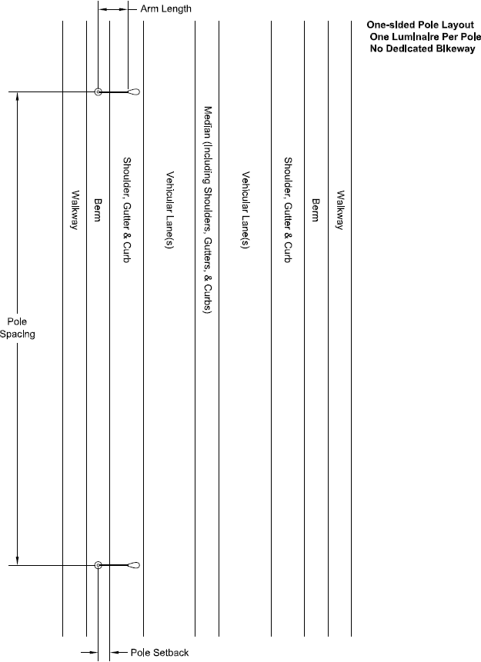
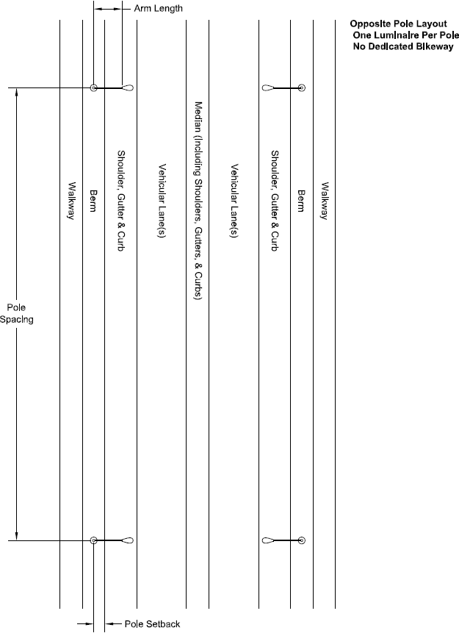
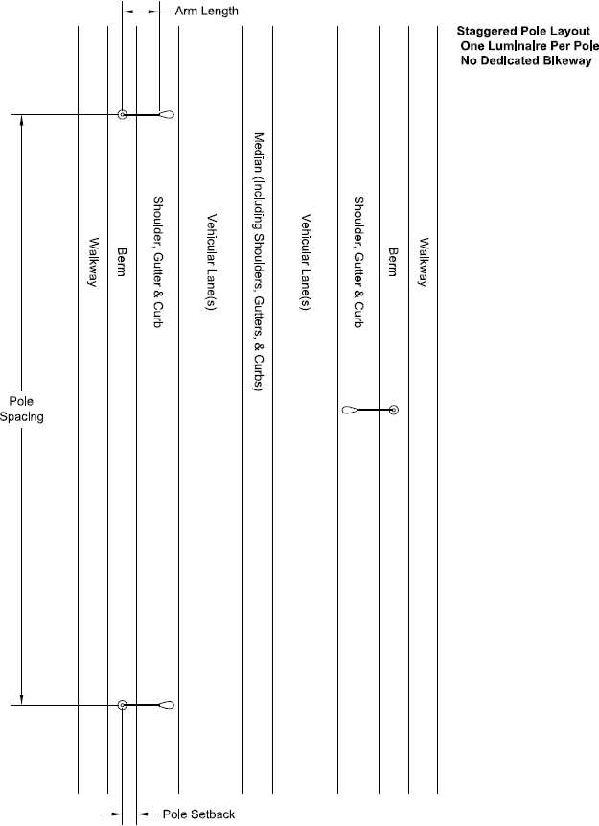
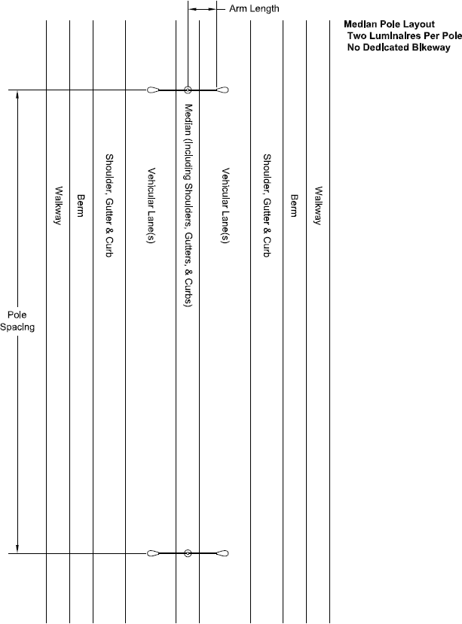

— Product Submittal Form
Luminaire designation | 70H
Luminaire manufacturer
Luminaire model number
Nominal IES TM-15 BUG ratings | B = |  |  | U = |  |  | G =
Product family testing | Submitted product is identical to tested product |  |  |  |  | Submitted product differs from tested product(s) as explained in attached letter
Housing finish color
Tenon nominal pipe size | inches
Nominal luminaire weight | lb
Nominal luminaire EPA | ft²
Nominal luminaire input voltage | V
Control interface | None | ANSI  C136.10 (3-pin) |  |  | ANSI  C136.41, 5-pin |  |  | ANSI  C136.41, 7-pin
LED driver | Not  dimmable |  | Dimmable,  0-10V (IEC 60929) |  |  |  | Dimmable, DALI (IEC 62386)
Electrical immunity—ANSI C136.2  combination wave test level | Basic  (6kV / 3kA) |  | Enhanced  (10kV / 5kA) |  |  |  | Elevated  (20kV / 10kA)
Upon failure of electrical immunity system | Possible disconnect |  |  |  |  | No possible disconnect
ANSI C136.31 vibration test level | Level 1 (Normal) |  |  |  |  | Level 2 (bridge/overpass)
Thermal management | Liquids or moving parts |  |  |  |  | No liquids or moving parts
Luminaire warranty period | Years
Rated life of LED driver(s) | Hours
IES LM-80 test duration | Hours
LED lumen maintenance * | Reported (restricted) |  |  |  |  | Calculated (unrestricted)
Make/model of LED light source(s)
 | Nominal value |  |  |  |  | Tolerance (%)
Luminaire input power—initial | W |  |  |  |  | W
Luminaire input power—maintained ** | W |  |  |  |  | W
LED drive current—initial | mA |  |  |  |  | mA
LED drive current—maintained ** | mA |  |  |  |  | mA
In-situ LED T_{s} | °C |  |  |  |  | °C
LED lumen maintenance ** | % |  |  |  |  | %
CCT | K |  |  |  |  | K
Additional product description

* Manufacturer shall indicate which is applicable (check only one box) as per section 5.6. According to IES TM-21, “Reported” values are restricted to 5.5x or 6x (depending on sample size) the duration of IES LM-80 testing, whereas “Calculated” (i.e., projected) values are unrestricted.
** As per section 5.6.

