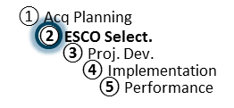
Agenda: PA Development Telecon
ESPC Process Doc. P2-08
Rev. 11-19-18
Responsibility: PF

PA Development Teleconference Call(s) Agenda
(minimum topics required to be covered are listed)

- Introductions
  - Agency CO & COR
  - ESCO Project Manager

- Status of PA development schedule
  - ESCO input on status of PA submittal schedule
  - Discuss timeline and pending actions

- Status of data collection from site visits
  - Discuss any issues (site access/security)

- Discuss any initial findings on ECMs

- Sources of savings (non-energy, O&M, etc.) and budget categories

- Government witnessing for M&V baseline (if measurements are made to support the IGA/proposal)

- Project discussion on meeting customer expectations

- Discuss availability of ESCO’s PA components for review prior to PA submittal
  - Risk/Responsibility Matrix
  - Utility rate baseline and escalation rates
  - Other/remaining components

