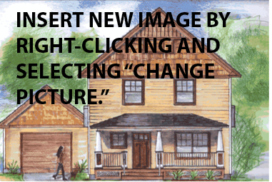
[Insert Collegiate Institution Name]
[Insert Contest Name]

Project Summary
[Summarize the project and provide a concise description of the project, including a brief identification of the target market. Explain the relevance of the project to the goals of the competition.] Replace this text with information about your project. Replace this text with information about your project. Replace this text with information about your project. Replace this text with information about your project. Replace this text with information about your project. Replace this text with information about your project. Replace this text with information about your project.

Replace this text with information about your project. Replace this text with information about your project. Replace this text with information about your project. Replace this text with information about your project.

Design Strategy
[Discuss how the team reached the project goals and contest definition.]
Replace this text with information about your design strategy. Replace this text with information about your design strategy. Replace this text with information about your design strategy. Replace this text with information about your design strategy. Replace this text with information about your design strategy.

Project Data
- [Insert location and climate zone]
- [Insert house, unit, or building square footage and lot size]
- [Insert number of bedrooms, bathrooms, stories, and occupants]
- [Residential: Insert Home Energy Ratings Score (HERS), Elem. School: Insert EUI target]
- [Insert estimated monthly utility cost]
- [Insert other relevant data here.]
Technical Specifications
- [Insert wall, foundation, and roof insulation = A, B, C]
- [Insert window performance = D]
- [Insert HVAC specifications = E]
- [Insert other technologies]
- [Insert renewable systems specifications]

[NOTE: All content above must fit on one page, organizers will extract the page for dissemination]

